Web Technologies Assignment (Part A)

Lucas Geurtjens (s5132841)

# Project Plan

## Client Background

The client is Umford Christian Students (UCS). UCS is a student-led ministry group at Umford University in Australia that aims to help students make friends and learn about Jesus. The group hosts a guest speaker and social event Tuesdays and a handful of smaller Bible studies throughout the week. As a student-led group, funding is limited. Nevertheless, after reaching out to various local Churches for the development and upkeep of a website, several have decided to sponsor the group. UCS wants a website that lets students know more about the group: who they are, when and where their key events are, and how they can get involved, as well as ways for interested students to submit contact details and find and join a Bible study.

## Goals

The following are the client’s goals for the website:

* Have an online presence that allows Umford University students to know that an on-campus Christian group exists.
* Provide up-to-date information about when and where the group meets.
* Present information about who the group is.
* Offer a way for interested students to get in contact with the group.
* Allow students to find and join a Bible study.

## Scope

The following is the scope of the website:

* The website will be created using only HTML, CSS, JavaScript, SQL, and PHP.
* No external framework will be used (e.g., React or Angular).
* All website components (tables, forms, etc.) will be created from scratch. Thus, there will be no pre-created HTML/CSS templates used.
* The site will use copyright-free images.
* A private GitHub repository will be used for source-control.
* The project will be completed by a single developer.
* A desktop and mobile version of the site will be created.
* Only the chrome browser will be tested during development. Thus, there will be no testing for browsers such as Firefox, Safari, Opera, Edge, Internet explorer etc.
* There will be no involvement with advertising the site or optimising how well it appears in search ranking.
* There will be no involvement in hosting the website, or anything related to production.
* There will be no login/account features for the website.
* There will be no form validation checks.
* The system will not notify users who register with an email/text, nor will it notify a group admin when a user registers.

## Target Audience

The target audience is university students (mostly young adults) attending Umford University, Australia, either Christian or exploring Christianity. Most students visiting the website will be using a mobile or laptop device, the latter often required for course work. These students would be using the website to get more information about the group (who they are and when and where they meet up), send the group contact details if they’re interested in coming along, and finding and joining a Bible study that fits with their timetable.

|  |  |
| --- | --- |
| **Occupation** | University student. |
| **Location of use** | Australia, Umford University. |
| **Beliefs** | Christian or exploring Christianity. |
| **Age** | Young adults (18-29 years old). |
| **Gender** | No specific gender. |
| **Language** | English. |
| **Need for the service** | To find more information about the group, to send contact details to the group, or to find and join a Bible study. |
| **Technical background** | Average. |
| **Internet speed** | Average. |
| **Access to devices** | Mobile and laptop. |
| **Screen resolution** | Laptop/desktop computers (approx. 1248px by 945px) or mobile (approx. 375px by 812px). |

## Requirements

### Functional

* The site should adhere to design conventions that make it easy for a user to understand.
* The front-end of the site should be developed using HTM, CSS, and JavaScript.
* The back-end database for the site should use SQL and PHP.
* The form for collecting contact details should be able to be submitted multiple times.
* The form for joining a Bible study should be able to be submitted multiple times, but not if the user has selected a Bible study that they are already a member of.
* The site should use media queries so that it’s responsive for desktop and mobile viewing.

### User

* Clickable elements should have a hover-over effect that let’s users know that the element is clickable.
* The user should be able to view the site on desktop or mobile.
* The site should have external links to the group’s Facebook and Instagram accounts.
* There should be a navigation bar that allows the user to click between pages.
* There should be a home page.
* There should be a page the provides up-to-date information about when and where the group meets.
* There should be a page that presents information about who the group is.
* There should be a page that offers a way for users to submit contact details. This should be done through a form that takes a first name, last name, email, and phone number.
* There should be a page that allows users to find and join a Bible study.
  + A table should display all available Bible studies (with fields ID, day, time, members).
  + A form should allow the user to submit their contact details (first name, last name, email, and phone number) and select which Bible study they want to join using a combo box (Its options being the concatenation of the ID, day, and time fields of all available Bible studies as seen in the table, for example: #5-Monday-12pm). Upon submission, they should be added to the Bible study.

### Business

* Have an online presence that allows more students to know that they exist.
* Have a website they can point people towards.

### Quality-of-Service

* Code should be well commented and formatted in a way that would make it easy for a future developer to understand.

# Site Design

## Desktop Wireframes

**Home page**

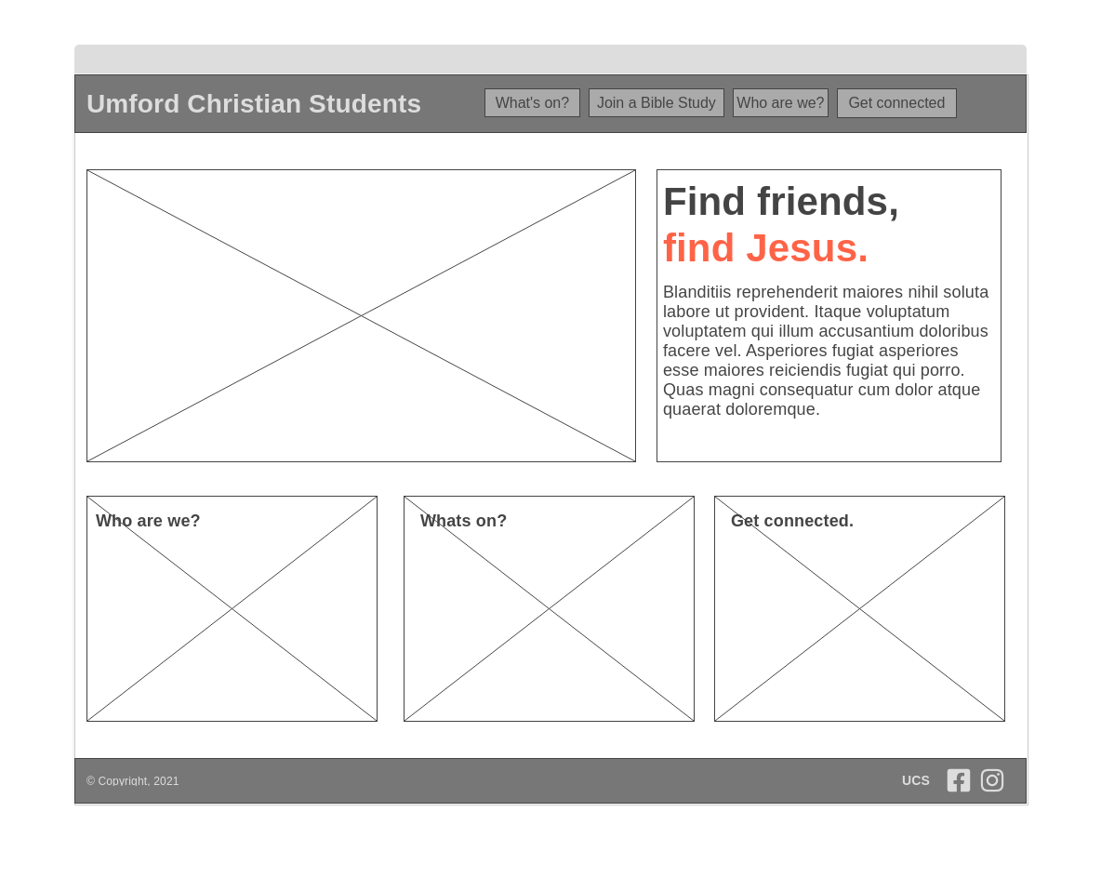

**[1]**

**[1]**

**[1]**

[1] The “Who are we?”, “What’s on?”, and “Get Connected.” images (with overlaying text) will act as links to those pages (as seen in the navigation bar).

**Get connected page**

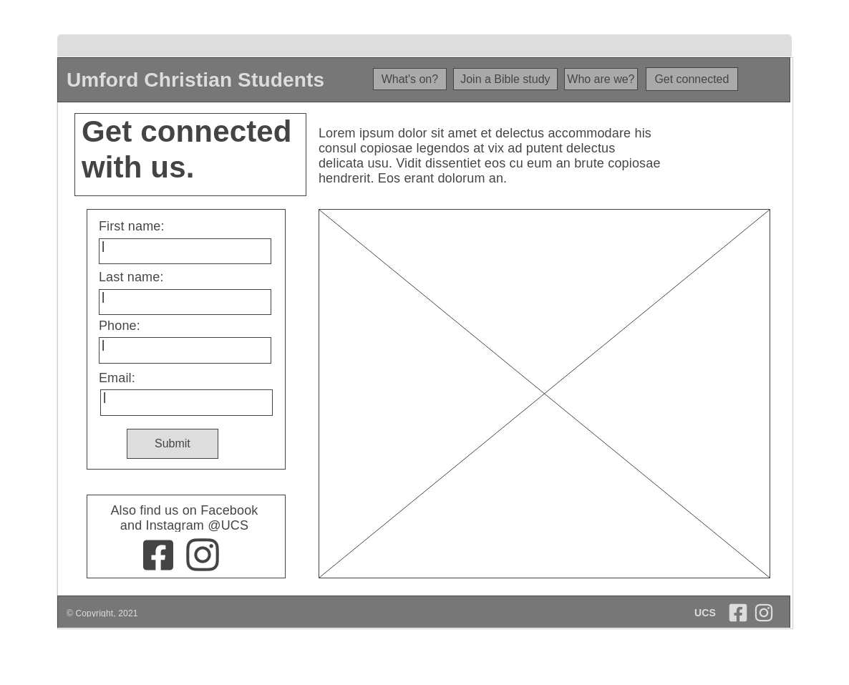

**[1]**

[1] Icons will link to their respective social media websites.

**Join a Bible study page**

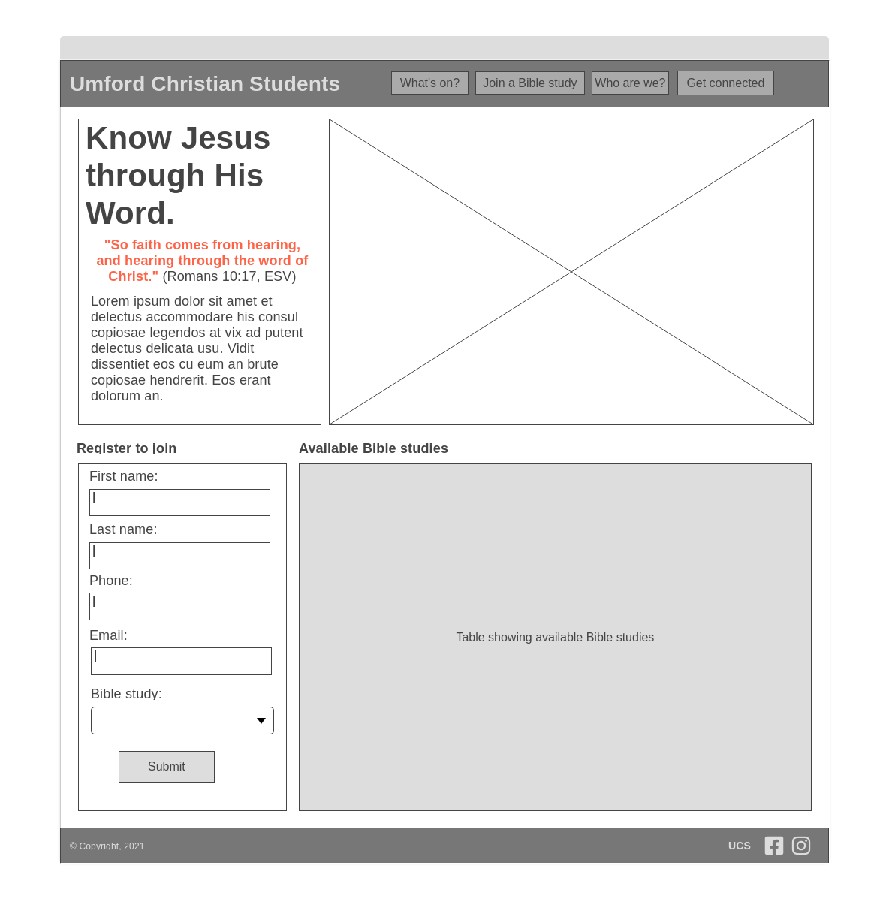

**[1]**

**[2]**

[1] The table will show all available Bible studies. The fields will include: ID, Day, Time, Location, and Members. It will be a scrollable table.

[2] The Bible study form combo box will use the concatenation of the ID, Day, and Time fields of the available Bible studies (as seen in the table) as its options (E.g., #4-Thursday-3pm).

**What’s on? page**

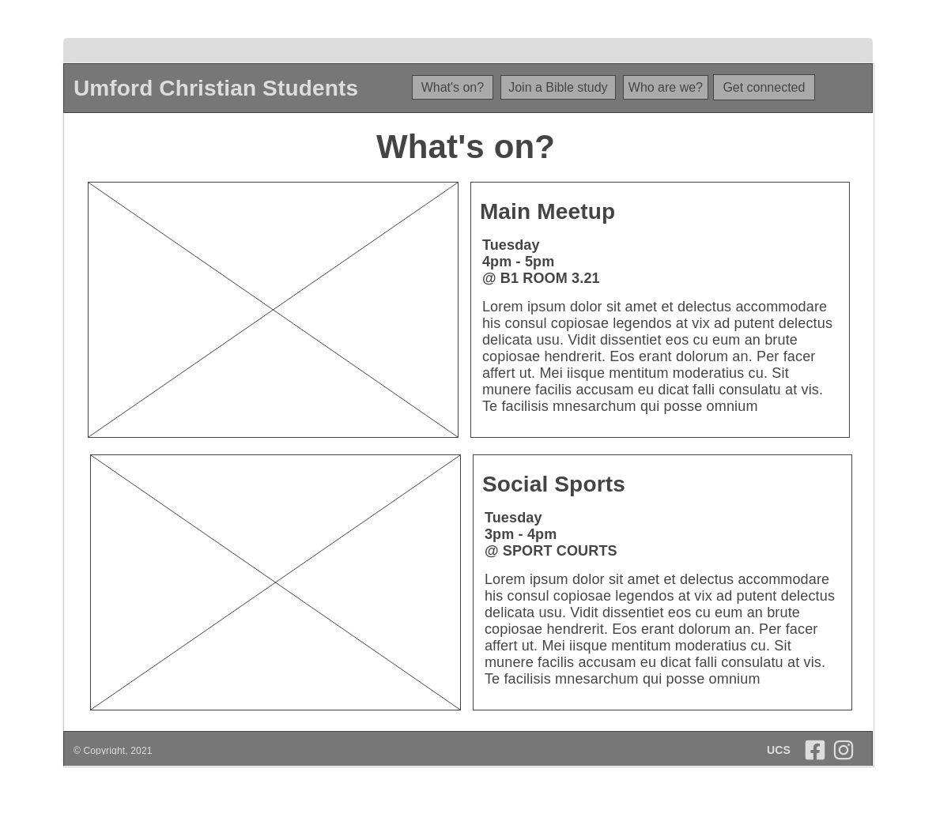

**Who are we? page**

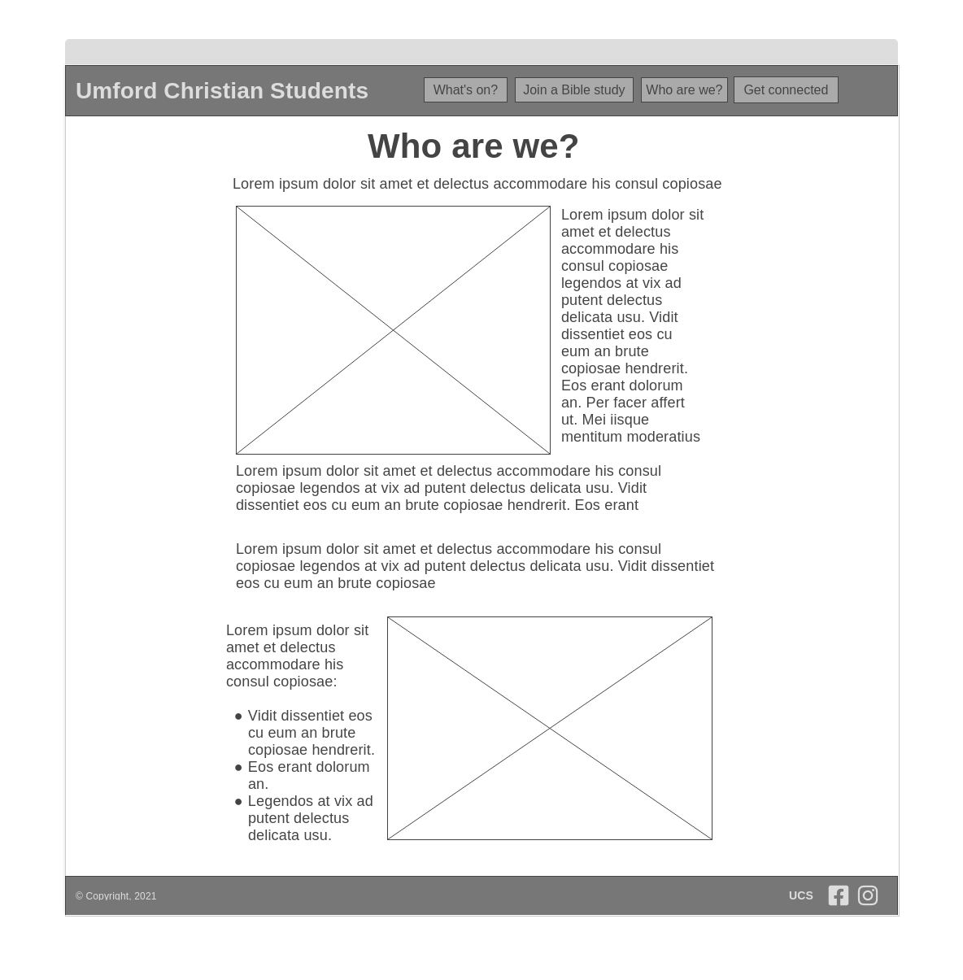

## Mobile Wireframes

**Get connected page**

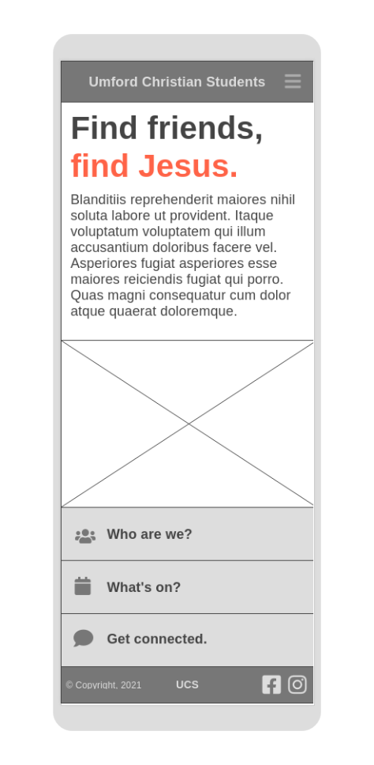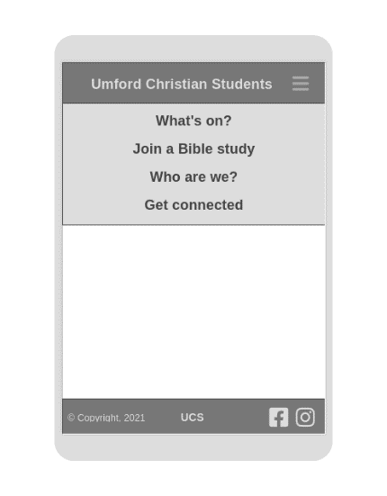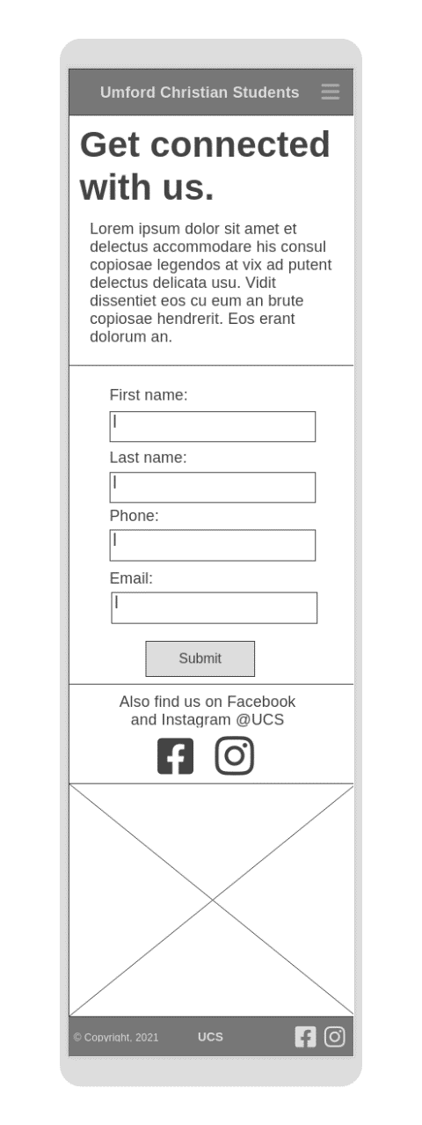

**Expanded Hamburger Button**

**Home page**

**Join a Bible study page**

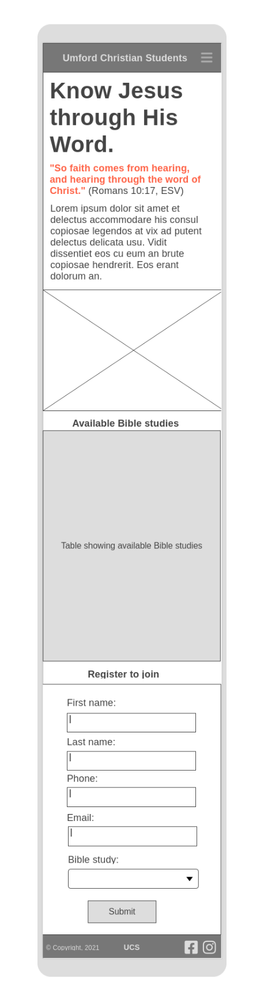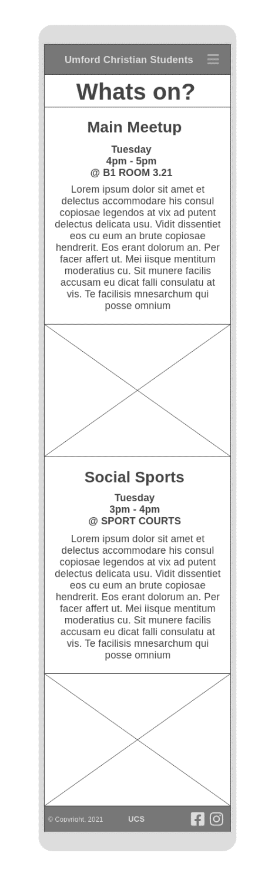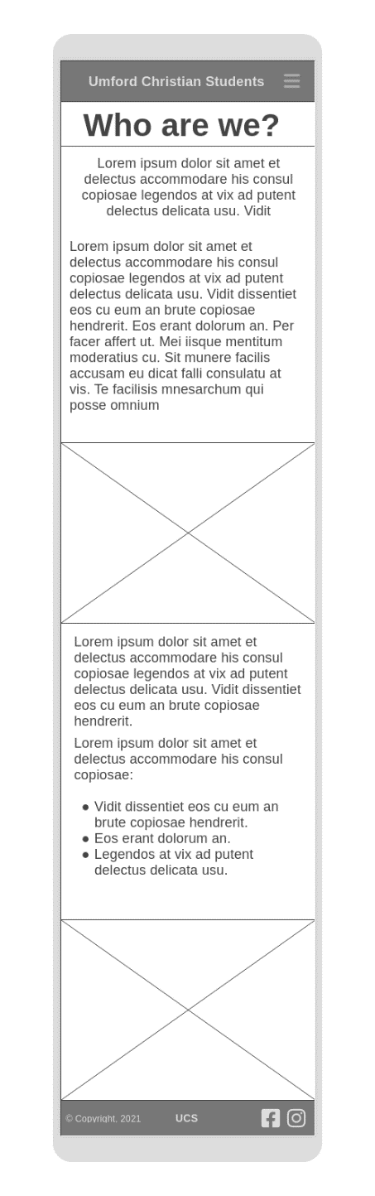

**Who are we? page**

**What’s on? page**

# Hierarchy Chart

